**ATAR Physics Year 12**

**Semester Two Examination, 2016**

**Question/Answer Booklet**

Student Name: _______**SOLUTIONS**___________________

**Time allowed for this paper**

Reading time before commencing work: 10 minutes

Working time for paper: 3 hours

**Materials required/recommended for this paper**

***To be provided by the supervisor***

This Question/Answer Booklet and the Formulae and Constants Sheet

***To be provided by the candidate***

Standard items: pens (blue/black preferred), pencils (including coloured), sharpener, correction tape/fluid, eraser, ruler, highlighters

Special items: non-programmable calculators approved for use in the WACE examinations, drawing templates, drawing compass and a protractor

**Important note to candidates**

No other items may be taken into the examination room. It is your responsibility to ensure that you do not have any unauthorised notes or other items of a non-personal nature in the examination room. If you have any unauthorised material with you, hand it to the supervisor before reading any further.

**Structure of this paper**

|  |  |  |  |  |  |
| --- | --- | --- | --- | --- | --- |
| **Section** | Number of questions available | Number of questions to be answered | Suggested working time (minutes) | Marks available | **Marks Attained** |
| Section One: Short answers | 13 | 13 | 54 | 54 (30%) | /54 |
| Section Two: Problem-solving | 7 | 7 | 90 | 90 (50%) | /90 |
| Section Three: Comprehension | 2 | 2 | 36 | 36 (20%) | /36 |
|  |  |  |  | 180 (100%) | /180 |

**Instructions to candidates**

Write your answers in the spaces provided beneath each question. The value of each question (out of 180) is shown following each question.

The enclosed Physics: Formulae and Constants Sheet may be removed from the booklet and used as required.

Calculators satisfying conditions set by the Curriculum Council may be used to evaluate numerical answers.

Answers to questions involving calculations should be evaluated and given in decimal form.

Give final answers to three significant figures and include appropriate units where applicable.

When calculating numerical answers, show your working or reasoning clearly. Despite an incorrect final answer, credit may be obtained for method and working, providing this is clearly and legibly set out.

Questions containing specific instructions to **show working** should be answered with a complete, logical, clear sequence of reasoning showing how the final answer was arrived at; correct answers which do not show working will not be awarded full marks.

Questions containing the instruction **estimate** may give insufficient numerical data for their solution. Students should provide appropriate figures to enable an approximate solution to be obtained. When estimating numerical answers, show your working or reasoning clearly. Give final answers to a maximum of two significant figures and include appropriate units where applicable.

**SECTION ONE: Short Response 54 marks (30%)**

This section has **15** questions. Answer **ALL** questions. Write your answers in the spaces provided.

Spare pages are included at the end of this booklet. They can be used for planning your responses and/or as additional space if required to continue an answer.

* Planning: If you use the spare pages for planning, indicate this clearly at the top of the page.
* Continuing an answer: If you need to use the space to continue an answer, indicate in the original answer space where the answer is continued, i.e. give the page number.

Fill in the number of the question(s) that you are continuing to answer at the top of the page.

Suggested working time for this section is **50 minutes.**

**Question 1 (4 marks)**

****The diagram below shows a simple AC generator, rotating at a frequency of 10 Hz. On the axes provided below, sketch the magnetic flux  through the coil and also the emf  induced as the coil rotates, starting from the position shown in the diagram.

**cosine curve (1)**

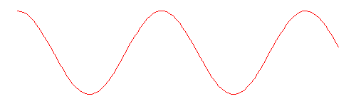



t(s)

0.2

0.1

**f = 10 Hz ➔ T = 0.1 s (1) ➔ 2 full cycles on each graph (1)**

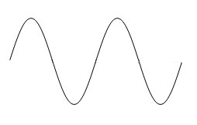



t(s)

0.2

0.1

**sine curve (1)**

**Question 2 (3 marks)**

A long jumper at the Rio Olympics launches himself into the air at a speed of 11.0 m/s and an angle of 22.5° to the horizontal in an attempt to beat the world record of 8.95 metres. Show by calculation whether or not he is successful.

**uv = u sin  = (11.0 m/s) sin 22.5° = 4.21 m/s**

**(1)**

**uh = u cos  = (11.0 m/s) cos 22.5° = 10.2 m/s**

**time in air t = 2 uv /g = 2(4.21 m/s)/9.8 m/s2**

**(1)**

**= 0.859 s**

**horizontal displacement sh = uh x t**

**= 10.2 m/s x 0.859 s = 8.73 m ∴ He is not successful (1)**

**Question 3 (4 marks)**

The relatively nearby star Tau Ceti, which is the closest solitary G-class star like our Sun, lies 11.9 light-years from Earth, and has five exoplanets, two of which lie in the "habitable zone" — that just-right range of distances that could support the existence of liquid water on the planets' surfaces. An interstellar spaceship from Earth is travelling to Tau Ceti at 90% of the speed of light.

(a) How far away is Tau Ceti (in light-years) to the astronauts on the spaceship? (2 marks)

**To the astronauts the distance to Tau Ceti is contracted due to the star moving towards the spaceship at 0.9c**

***l* = *l*0 (1 - v2/c2) ½ (1)**

**= 11.9 (1 – 0.92) ½**

**= 5.19 light-years (1)**

(b) How long will the spaceship take to reach Tau Ceti

(i) from the reference frame of observers on Earth? (1 mark)

**t = 11.9 lyr/ 0.9c = 13.2 years**

(ii) from the reference frame of the astronauts on the spaceship? (1 mark)

**t = 5.19 lyr/ 0.9c = 5.76 years**

**Question 4 (3 marks)**

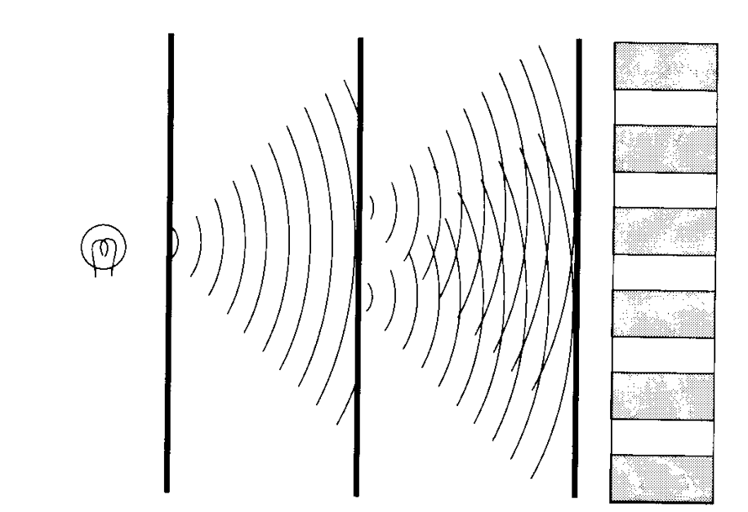The diagram at right illustrates Young’s famous double-slit experiment, which was crucial in helping us to understand the nature of light. Briefly describe how the experiment worked, and explain the insight it gave into the nature of light.

**Light from a source passed through a slit in a screen and was diffracted onto another screen that had two slits. The light diffracted through each of these slits (1) , forming two overlapping beams that produced a pattern of alternating bright and dark bands on a third screen. (1) This pattern was characteristic of an interference**

**pattern, and indicated that light was wave-like in nature. (1)**

**Question 5 (4 marks)**

A satellite orbits the Earth in a circular orbit at an altitude of 4000 km. Calculate

(a) the centripetal acceleration experienced by the satellite. (2 marks)

**ac = g = GM/r2 (1)**

**= (6.67 x 10-11)(5.97 x 1024)/(6.37 x 106 + 4 x 106)2**

**= 3.70 m/s2 (1)**

(b) the orbital speed of the satellite. (2 marks)

**ac = v2/r ➔ v2 = ac x r (1)**

**v2 = 3.70 m/s2 x (6.37 x 106 + 4 x 106) ➔ v = 6.20 x 103 m/s (1)**

**[ Or could use v = (GM/r)½ ]**

**Question 6 (5 marks)**

The diagrams below show a long straight vertical wire (diagram A) and a solenoid (diagram B). Arrows indicate the direction of the current through each of the conductors.

**A B**

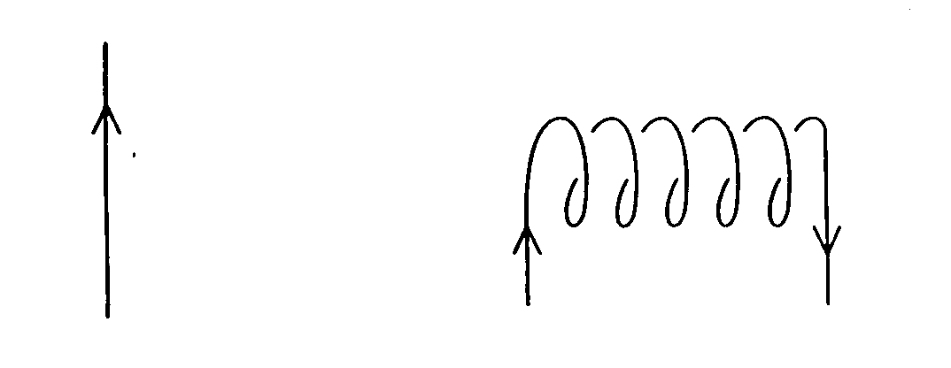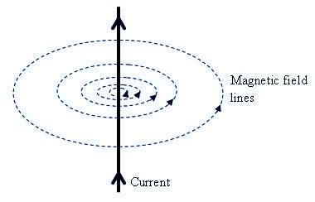

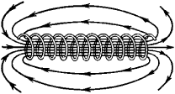

**each diagram: shape (1) , direction (1) (-1 for each mistake)**

(a) Sketch on each diagram the magnetic field produced by each conductor. (3 marks)

(b) In diagram A the magnetic field strength is found to be 45 T at a perpendicular distance of 1.75 cm from the long straight wire. Calculate the size of the current in the wire. (2 marks)

**B = 0/2 I/r ➔ 45 x 10-6 = (2 x 10-7) I/(0.0175)**

**∴ I =** **45 x 10-6 x (0.0175)/(2 x 10-7) = 3.94 A (2)**

**Question 7 (5 marks)**

A proton is accelerated in the Large Hadron Collider at CERN in Geneva up to 99.995% of the speed of light. At this speed, calculate

(a) the mass of the proton (2 marks)

**m = m0 /(1 - v2/c2)½**  **=** **1.67 x 10-27 /(1 - 0.999952 )½**

**= 1.67 x 10-27 /(1 - 0.999952 )½ = 1.67 x 10-25 kg (2)**

(b) its momentum (1 mark)

**p = m v = 1.67 x 10-25 kg x (0.99995 x 3 x 108 m/s) = 5.01 x 10-17 kgm/s (1)**

(c) the wavelength of the proton (2 marks)

** = h/p (1)**

**= 6.63 x 10-34/5.01 x 10-17 = 1.32 x 10-17 m (1)**

**Question 8 (4 marks)**

The diagrams below show the interaction between a bar magnet and a solenoid in three different situations. The needle of the galvanometer, shown below the solenoid, indicates any flow of current.

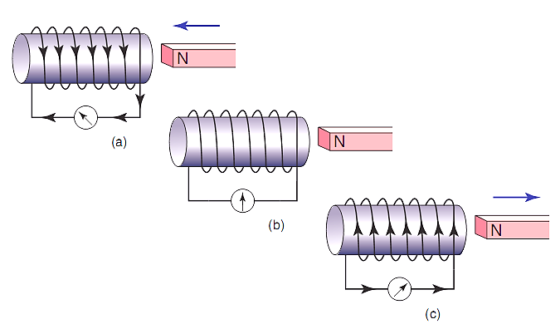

Briefly explain the following observations:

(a) No current flows (diagram b) when the magnet is held stationary near the solenoid. (1 mark)

**When the magnet is held stationary near the solenoid there is no change of flux through the solenoid, and hence no emf is induced in the solenoid.**

(b) The current flows in opposite directions in diagrams (a) and (c) when the magnet is pushed towards, then pulled away from the solenoid. (3 marks)

**When the magnet is moved relative to the solenoid there is a change of flux through the solenoid and an emf is induced in the solenoid that causes current to flow. (1)**

**The induced current always flows in a direction such that its magnetic field opposes the flux change that generated it (Lenz’s Law). (1) Hence the current must flow in opposite directions when the magnet is pushed towards or pulled away from the solenoid as these motions produce opposite flux changes in the solenoid. (1)**

**Question 9 (5 marks)**

A photoelectric cell contains an aluminium electrode that is illuminated with ultraviolet light of wavelength 284 nm. The work function of aluminium is 4.08 eV. Calculate

(a) the energy of one of the ultraviolet photons in electron-volts. (2 marks)

**E = hc/ = (6.63 x 10-34)(3 x 108)/(2.84 x 10-7)**

**= 7.00 x 10-19 J = 4.38 eV (2)**

(b) the velocity of the emitted photo-electrons. (3 marks)

**EK = hf - W = 4.38 eV - 4.08 eV = 0.297 eV (1)**

**EK = 4.76 x 10-20 J (1)**

**EK = ½ mv2 (1)**

**½ (9.11 x 10-31) v2 = 4.76 x 10-20**

**v =** **3.23 x 105 m/s**

**Question 10 (3 marks)**

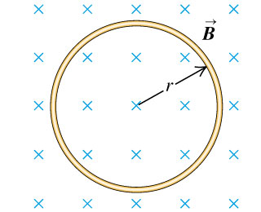The diagram at right shows a ring of wire of radius r = 2.00 cm, which is fully immersed in a uniform magnetic field B = 50.0 mT. The ring is pulled quickly out of the magnetic field, taking 0.15 s to be clear of the magnetic field.

(a) Indicate on the ring the direction of any induced current.

(1 mark)

**current is clockwise**

(b) If the ring has a resistance of 0.03 Ω, find the size of the average current induced as the ring is pulled clear of the magnetic field. (2 marks)

**  = /t = (0.050 T)(  (0.02m)2 )/(0.15s) = 4.19 x 10-4 V (1)**

**  = /R = (4.19 x 10-4 V)/0.03  = 0.0140 A (1)**

**Question 11 (5 marks)**

Observations of the luminosity of a supernova in a distant galaxy indicate that it is 50 mega parsecs away from Earth. Analysis of the helium spectrum from the supernova shows that the yellow line that usually occurs at a wavelength of 587.6 nm was measured for this galaxy to be at 595.3 nm.

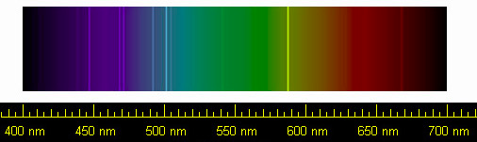

(a) What has caused this change in wavelength of the yellow line in the helium spectrum for this distant galaxy? (1 mark)

**The wavelength of the yellow line has increased, indicating a Doppler shift due to the distant galaxy moving away from the Earth.**

**OR The expansion of space that stretches the wavelength out.**

(b) The recessional velocity of a galaxy can be calculated from spectral data using

$$v=\frac{∆λ}{λ_{0}}c$$

where $∆λ$ is the difference in the wavelength and $λ_{0}$ is the wavelength when measured at rest with the light source. (2 marks)

**Δλ = 595.3 nm - 587.6 nm = 7.7 nm (1)**

**v = (Δλ/λ) c = (7.7 nm/587.6 nm) (3 x 108 m/s) = 3.93 x 106 m/s (1)**

(c) Use the data from this galaxy to estimate a value for Hubble’s constant Ho. (2 marks)

**v = Ho d ➔ Ho = v/d = (3.93 x 106 m/s)/50 Mpc (1)**

**= (3930 km/s)/50 Mpc = 78.6 km/s/Mpc (1)**

**Question 12 (5 marks)**

An electron is fired into a uniform perpendicular magnetic field of strength 230 μT and follows a semi-circular path through the magnetic field of radius 350 mm, as illustrated at right.

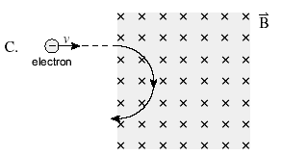

(a) Calculate the speed needed for the electron to follow the semi-circular path. you may ignore any relativistic effects. (2 marks)

**r = m v/q B v = r q B/m (1)**

**∴ v = (0.35 m) (1.6 x 10-19 C) (230 x 10-6 T)/(9.11 x 10-31 kg)**

**= 1.41 x 107 m/s (1)**

(b) Determine the potential difference through which the electron was accelerated (before reaching the magnetic field) in order to have this speed. (3 marks)

**W = V q = EK (1)**

**EK = ½ mv2 = ½ (9.11 x 10-31 kg)(1.41 x 107 m/s)2 = 9.11 x 10-17 J (1)**

**∴** **V = EK /q = 9.11 x 10-17 J /1.6 x 10-19 C = 569 V (1)**

**Question 13 (4 marks)**

There are 6 different quarks, which are shown in the table below. Quarks interact strongly with one another and exist in combination as composite particles called hadrons. There are two classes of hadrons – baryons, made of three quarks, and mesons, made of a quark-antiquark pair.

|  |  |  |  |  |  |  |  |
| --- | --- | --- | --- | --- | --- | --- | --- |
| **NAME** | **SYMBOL** | **Charge (Q)** | **Baryon Number (B)** | **Strangeness (S)** | **Charm**  **(c)** | **Bottomness (b)** | **Topness**  **(t)** |
| *Up* | u | $+\frac{2}{3}$ e | $$\frac{1}{3}$$ | 0 | 0 | 0 | 0 |
| *Down* | d | $-\frac{1}{3}$ e | $$\frac{1}{3}$$ | 0 | 0 | 0 | 0 |
| *Strange* | s | $-\frac{1}{3}$ e | $$\frac{1}{3}$$ | -1 | 0 | 0 | 0 |
| *Charm* | c | $+\frac{2}{3}$ e | $$\frac{1}{3}$$ | 0 | +1 | 0 | 0 |
| *Bottom* | b | $-\frac{1}{3}$ e | $$\frac{1}{3}$$ | 0 | 0 | -1 | 0 |
| *Top* | t | $+\frac{2}{3}$ e | $$\frac{1}{3}$$ | 0 | 0 | 0 | +1 |

(a) Compare the baryon number for the tow different types of hadrons. (2 marks)

**Baryon number of +1 for a baryon 1**

**Baryon number of 0 for meson 1**

(b) Give the quark composition of each of the following hadrons: (2 marks)

(i) the baryon 0 which has Q = 0, B = 1, S = -1 and c = b = t = 0

**u d s**

(ii) the meson K+ which has Q = +1, B = 0, S = +1 and c = b = t = 0

**_**

**u s**

**End of Section One**

**SECTION TWO: Problem-solving** **90 marks (50%)**

This section has **7** questions. Answer **ALL** questions. Write your answers in the spaces provided.

Spare pages are included at the end of this booklet. They can be used for planning your responses and/or as additional space if required to continue an answer.

* Planning: If you use the spare pages for planning, indicate this clearly at the top of the page.
* Continuing an answer: If you need to use the space to continue an answer, indicate in the original answer space where the answer is continued, i.e. give the page number. Fill in the number of the question(s) that you are continuing to answer at the top of the page.

Suggested working time for this section is **90 minutes.**

**Question 16 (12 marks)**

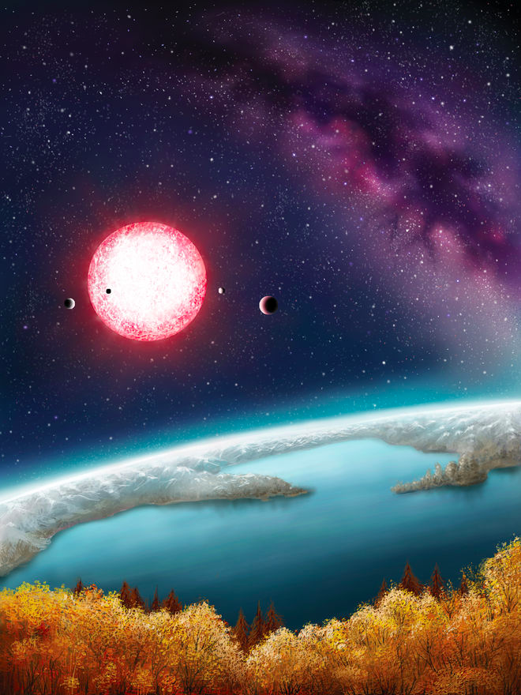Kepler-186f is one of five planets found in an extrasolar system located about 490 light-years from Earth. The newly discovered exoplanet orbits about 52.4 million kilometres from its sun. It takes Kepler-186f about 130 days to orbit its red dwarf star. Kepler-186f is the first Earth-size alien planet found in the habitable zone of its star. That means the planet, which is about 10% larger in diameter than Earth, is in the part of its star system where liquid water could exist on the planet's surface. An artist’s impression of the planet’s surface is pictured at right.

(a) What is the orbital speed of Kepler-186f?

(2 marks)

**v = 2r/T (1)**

**= 2(5.24 x 1010 m)/(130 x 86400 s)**

**= 2.93 x 104 m/s (1)**

(b) Is Kepler-186f accelerating? Explain. (2 marks)

**Yes, Kepler-186f is accelerating (1) as it orbits as it is continually changing direction and therefore continually changing velocity due to the gravitational pull of its sun. (1) (although its orbital speed stays roughly constant)**

(c) From the orbital data about Kepler-186f, calculate the mass of its red dwarf sun. (3 marks)

**Kepler’s 3rd Law states**

**r3/T2 = GM/42  (1)**

**(5.24 x 1010 m)3/(130 x 86400 s)2 = (6.67 x 10-11 Nm2/kg2)M/42 (2)**

**M = 6.75 x 1029 kg**

(d) Assuming that Kepler-186f has a similar density to Earth, calculate a value for its mass based upon its size. (2 marks)

**Kepler-186f has a diameter and hence radius that is 1.1 times larger than that of Earth**

**Since mass = density x volume = density x 4/3r3 (1)**

**mass(Kepler-186f) = mass(Earth) x 1.13**

**= 5.97 x 1024 kg x 1.331 = 7.95 x 1024 kg (1)**

(e) Hence find a value for the gravitational force between Kepler-186f and its sun. (3 marks)

**F = G m1 m2/r2 (1)**

**= (6.67 x 10-11 Nm2/kg2)(6.75 x 1029 kg)( 8 x 1024 kg)/ (5.24 x 1010 m)2 (2)**

**= 1.30 x 1023 N**

**Question 17 (12 marks)**

The series of diagrams below show a very fast train, with a woman standing on an open carriage, speeding at a relativistic velocity past a man standing on the ground next to the train tracks. Just as the train passes the man, two bolts of lightning strike the front and rear of the train.

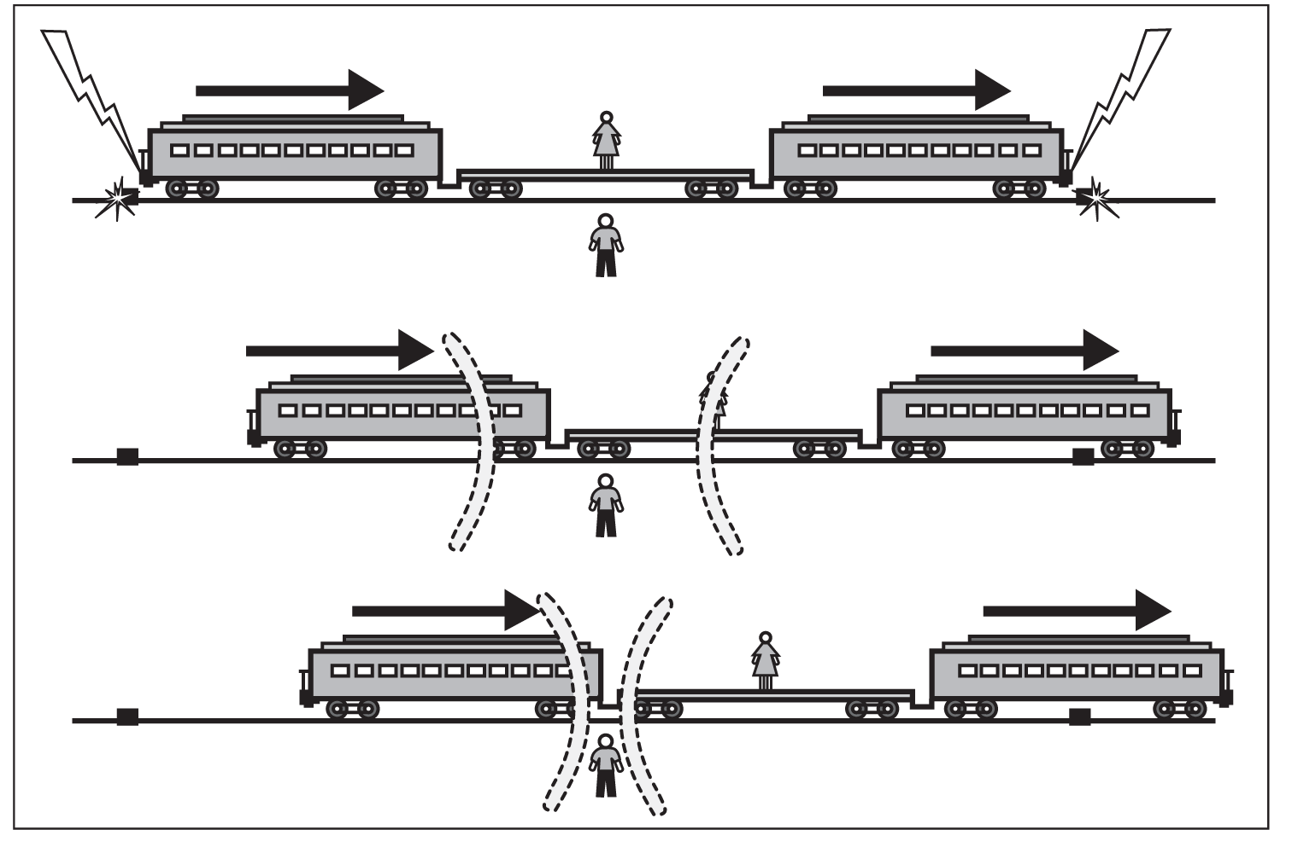

(a) What is the order in time of the two lightning strikes according to

(i) the man standing on the ground. (1 mark)

**simultaneously**

(ii) the woman standing on the train carriage. (1 mark)

**the front of the train occurred before the rear**

(b) Whose interpretation of events is correct, the man’s or the woman’s? Briefly explain. (2 marks)

**Both interpretations are equally correct (1) as each person is moving in their own inertial frame of reference, and no inertial frame is preferred to any other (1)**

**(each person in their own frame can use their interpretation of events to explain why the other person interprets the time order of the events differently)**

(c) How can the man explain the order of the events as observed by the woman? (2 marks)

**The woman is moving towards the strike at the front of the train requiring the light to travel a shorter distance and reach her before the strike at the back.**

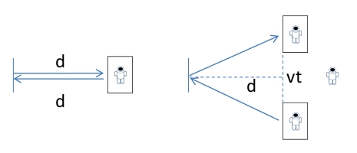In a futuristic scenario, an astronaut aboard a relativistic spacecraft conducts a simple experiment (diagram A), by shining a beam of light onto a mirror that is a distance d away, and timing how long the reflection takes to return to her. Her value for the time taken by the light to travel to the mirror and back is

**l**

**l**

A

B

t0 = 2d/c (equation 1)

While she conducts this simple experiment, a second astronaut observes the experiment from a space station as the relativistic spacecraft speeds past at velocity v. He sees the beam of light follow the path shown in diagram B due to the motion of the spacecraft.

(c) Show that the time he measures for the light travelling to the mirror and back is given by the expression (3 marks)

$t = \frac{2 \sqrt{d^{2}+\frac{1}{4}v^{2}t^{2}}}{c}$ (equation 2)

**The light travels a distance 2l in his reference frame at the same constant speed c, so the time the light takes is given by**

**t = 2l/c (1)**

**where l is the hypotenuse of a right-angled triangle with other sides d and ½ vt**

**∴ l = ( d2 + (½vt)2 ) ½ = ( d2 + ¼v2t2 ) ½ (1)**

**Hence t = s/v = 2 (d2 + ¼v2t2)½/c (1)**

(d) By combining equations 1 and 2, derive a formula linking the two different time intervals, as measured by the astronauts, for this simple experiment. (3 marks)

**Rearranging equation 2 gives ct/2 = ( d2 + (½vt)2 ) ½**

**Squaring both sides gives**

**(½ct)2 = d2 + (½vt)2 ➔ (½ct)2 - (½vt)2 = d2 (1)**

**Equation 1 gives d2 =** **(½ct0)2 so that**

**(½ct)2 - (½vt)2 = (½ct0)2 ➔ c2t2 - v2t2 = c2t02 (1)**

**t2 (c2 - v2) = c2t02 ➔ t2 (c2 - v2)/ c2 = c2t02/c2**

**t2 (1 - v2/c2 ) = t02 ➔ t = t0 (1 - v2/c2 ) -½ (1)**

**Question 18 (13 marks)**

The diagram below shows an iron-cored transformer

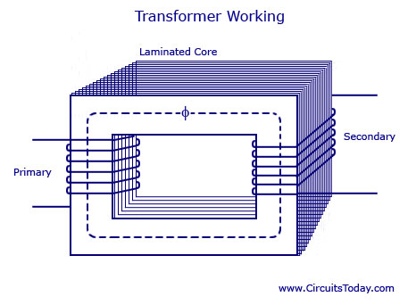

(a) Explain how energy is transferred from the primary coil to the secondary coil, with reference to *Faraday’s Law of* *electromagnetic induction.* (3 marks)

**The alternating current in the primary coil produces magnetic flux that continually varies in size as well as oscillating back and forth in direction. (1)**

**This continually varying flux is channelled by the iron core of the transformer and directed through the secondary coil of the transformer (1) , where, by Faraday’s Law of electromagnetic induction, it induces an emf in the secondary coil due to the continually varying flux, thereby transferring energy from primary coil to secondary coil. (1)**

(b) What is a ***laminated*** core, and what is its purpose? (2 marks)

**A laminated core is composed of thin slices of iron glued together by an electrically insulating material. (1)**

**Its purpose is to greatly restrict the formation of eddy currents in the iron core so as to limit loss of energy through heating of the core. (1)**

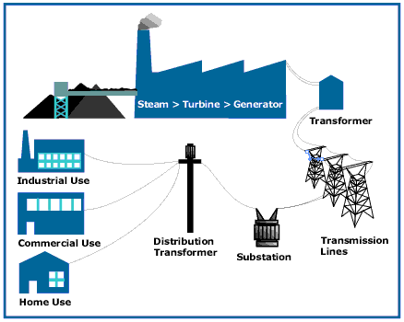In order to transmit electric power more efficiently, an electricity company uses transformers and high voltage transmission lines to transmit power at 330 kV from the power station to the city 200 km away. The average output power of its generators is 600 MW during the high demand period from 3pm to 9pm on a hot summer day. The high voltage transmission lines have a total resistance of 5.00 Ω over their 200 km length.

(c) What is the voltage at the end of the transmission lines (before the substation) after transmission along the high voltage lines? (3 marks)

**Current flow needed in the lines to deliver the output power from the power station is**

**I = P/V = (600 x 106 W)/(330 x 103 V) = 1820 A (1)**

**Voltage drop along the lines is**

**V = I R = 1820 A x 5.00  = 9090 V (1)**

**Hence the voltage at the end of the transmission lines is**

**330 000 V - 9090 V = 321 000 V = 321 kV (1)**

(d) Calculate the percentage power loss in the high voltage transmission lines. (2 marks)

**Power loss in the transmission lines is**

**P = I2 R = (1820 A) 2 (5.00 ) = 16.5 MW (1)**

**Hence the percentage power loss in the transmission lines is**

**%P(loss) = 16.5 MW/600 MW x 100% = 2.75% (1)**

(e) Given that the energy content of coal is 24 MJ per kilogram, and that the process of generating electrical energy in a coal fired power station is 40% efficient, calculate the mass of coal needed to supply the electrical energy required during the high demand period from 3pm to 9pm on a hot summer day. (3 marks)

**Electrical energy required during the high demand period is**

**E = P x t = (600 x 106 W) x (6 x 60 x 60 s) = 1.30 x 1013 J (1)**

**Energy needed from coal (power station is only 40% efficient) is**

**1.30 x 1013 J/0.40 = 3.24 x 1013 J (1)**

**Hence the mass of coal needed is**

**3.24 x 1013 J/(24 x 106 J/kg) = 1.35 x 106 kg ( = 1350 tonne) (1)**

**Question 19 (11 marks)**

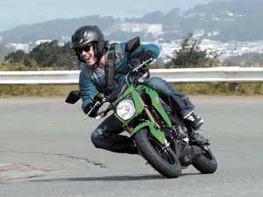A man rides a motorcycle around a flat curve in the road at a constant speed of 54.0 km/h. The man and motorcycle have a combined mass of 185 kg and the curve has a radius of curvature of 35.0 m. The rider must lean over as he corners.

**reaction force of road R (1)**

(a) Show the physical forces acting on the man as he rides the motorcycle around the corner. Use labelled arrows in the picture at right. (2 marks)

**-1 for additional forces**

**weight W (1)**

(b) Explain why the rider has to lean over as he corners on the motorcycle. (3 marks)

**In order to follow a curved path around the corner there must be a centripetal force acting on the motorcycle. (1)**

**By leaning inwards as he corners, the rider causes the tyres of the motorcycle to push outwards with a friction force on the road. (1)**

**The reaction force of the road friction pushing inwards on the tyres provides the necessary centripetal force for the motorcycle to negotiate the curve. (1)**

(c) Calculate the force of friction acting on the tyres of the bike. (2 marks)

**Ffr = Fc = mv2/r (1)**

**= (185 kg)(15 m/s)2/(35.0 m) = 1190 N (1)**

(d) What is the size of the total force exerted by the road on the tyres? (2 marks)

**Reaction force R exerted by the road on the tyres has two components**

**RH = Ffr = 1190 N and RV = W = 185 x 9.8 = 1810 N (1)**

**Hence R = $\sqrt{{R_{H}}^{2}+ {R_{V}}^{2}}$**  **= $\sqrt{{1190}^{2}+ {1810}^{2}}$ = 2170 N (1)**

(e) What is the angle that the bike and rider make to the horizontal? (2 marks)

**The angle  that the bike and rider make to the horizontal is given by**

**tan  = RV/RH = 1810/1190 (1)**

**∴  = 56.7° (1)**

**Question 20 (15 marks)**

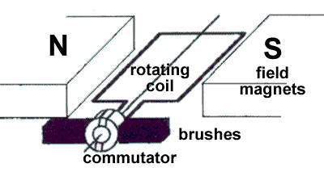A typical DC electric motor is shown at right. The coil contains 250 turns and has dimensions of 8.00 cm in length by 5.00 cm in width. The field magnets produce a uniform magnetic field of strength 0.0240 T in which the coil rotates.

(a) Explain the purpose of the commutator and brushes. (2 marks)

**The brushes provide a sliding electrical contact to the rotating commutator (1), while the split ring reverses the current flow every half turn of the coil so that the torque always acts in the same rotational direction. (1)**

(b) Describe two ways that an *actual* electric motor would differ from the one shown in the diagram above. (2 marks)

**Any two of the following points**

* **curved magnetic poles**
* **electromagnets for the poles (stator coils), rather than permanent magnets**
* **multiple armatures, rather than a single coil**
* **segmented commutator, rather than a split ring commutator**

(c) When in operation under load, the motor rotates at a steady rate of 750 rpm (revolutions per minute) and draws a current of 3.00 A. On the axes below, sketch the torque produced by the motor over a full rotation of the coil, starting from the position shown in the diagram above. Include appropriate scales on both axes. (4 marks)

**f = 750 rpm = 12.5 Hz ➔ T = 1/f = 1/12.5 Hz = 0.08 s (1)**

**max  = N I A B = (250)(3.00 A)(0.08 m x 0.05 m)(0.0240 T) = 0.072 Nm (1)**

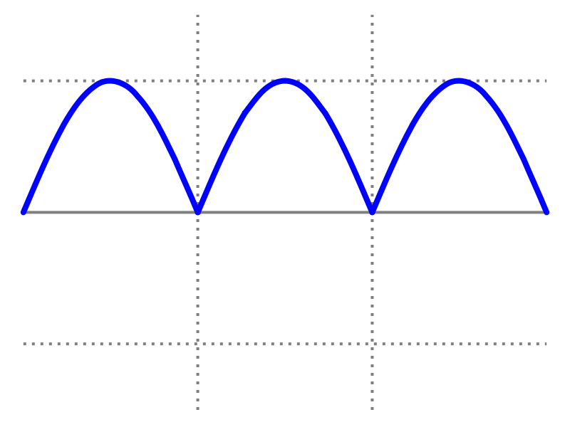

** (Nm)**

**t(s)**

**0.08**

**0.072**

**labelled, scaled axes (1) rectified cosine curve (1)**

(d)

(d) Even when under no load at all, the motor has a maximum rotational speed that it can reach. Explain why this is so, with reference to Faraday’s Law and Lenz’s Law. (4 marks)

**As the motor gains speed due to the torque produced by the interaction between the current and the magnetic field, the rotating coil cuts magnetic flux. (1)**

**According to Faraday’s Law, the changing magnetic flux through the coil will induce an emf in the coil. (1)**

**By Lenz’s Law, this induced emf will act so as to oppose the external emf that is driving the motor. (1)**

**As the motor speeds up the induced emf ( usually called the back emf) will increase until it balances the external emf, at which point the motor will have reached its maximum rotational speed. (1)**

(e) Estimate the maximum rotational speed of the motor (in rpm) when connected to a 6.00 V battery and operating under no load. (3 marks)

**Maximum rotational speed occurs when the back emf reaches 6.00 V**

**rms = = 6.00 V (1)**

**= $\frac{2π(0.024 T)(0.08 m x 0.05 m)(250)f}{\sqrt{2}}$ = 6.00 V (1)**

**f = 56.3 Hz = 3380 rpm (1)**

**If based on the peak emf reaching 6.00 V, (max 2 marks)**

$ε_{peak}=2πNBAf$

$f=39.7 Hz$

$f=39.7*60=2387 rpm$

**Question 21 (12 marks)**

The figure at right illustrates some of the valence electron energy levels in a gaseous atom of a particular element. The energies of the levels are given in electron volts (eV).

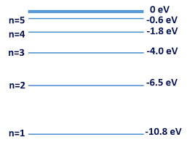

(a) The valence electron of the atom is in the lowest energy level shown. What is the ionisation energy of the atom in joules? (2 marks)

**Ionisation energy = 10.8 eV (1)**

**= 10.8 x 1.6 x 10-19 J**

**= 1.73 x 10-18 J (1)**

(b) State two physical processes by which an electron in the ground state can move to a higher energy level. (2 marks)

**Any two of the following points**

* **absorption of a photon of energy exactly equal to the energy level difference**
* **bombardment by an electron with sufficient KE to excite the atom**
* **thermal excitation whereby if the sample of gas is hot enough then atomic collisions may be energetic enough to excite atoms**

A cold gaseous sample of the element is bombarded by electrons of energy 9.5 eV and observed to emit electromagnetic radiation.

(c) Show on the diagram above all the energy level transitions that could emit electromagnetic radiation after the gas sample was excited. (2 marks)

**9.5 eV can excite atoms up to level n = 4 (1) ➔ 6 emission lines (1)**

(d) Calculate the longest wavelength of the emitted electromagnetic radiation. (3 marks)

**Longest wavelength of radiation = smallest energy = 2.2 eV (n = 4 to 3) (1)**

**E = hc/ ➔   = hc/E = (6.63 x 10-34)(3 x 108)/(2.2 x 1.6 x 10-19) (2)**

**= 5.65 x 10-7** **m**

Invisible ultraviolet light of photon energy 6.8 eV is shone through a cold gaseous sample of the element, which is then observed to glow with a turquoise-blue light.

(f) Calculate the frequency of the turquoise-blue light. (3 marks)

**6.8 eV excites atoms to level n= 3**

**n = 3 to n = 2 releases photon with 2.5 eV ➔ visible light (1)**

**(n = 2 to n = 1 releases photon with 4.3 eV ➔ ultraviolet light)**

**E = h f ➔ f = E/h = (2.5 x 1.6 x 10-19 J)/(6.63 x 10-34 Js)**

**= 6.03 x 1014** **Hz (2)**

**Question 22 (15 marks)**

A mobile crane is used to lift a load m of mass 1600 kg, as shown in the diagram below. The 18 m long boom (crane arm) has a mass of 850 kg, centred halfway along its length, and can pivot about point P at its base.

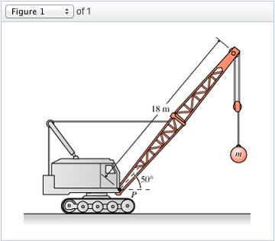

**W(load)**

**W(boom)**

**Tension of cable**

**Reaction of pivot**

(a) Clearly show all forces acting on the boom as labelled arrows on the diagram. (3 marks)

**Tension (1) Reaction of pivot (1) Weight forces (1)**

(b) A horizontal steel cable connects to the boom 8.00 m from the pivot P. Find the tension in the cable needed to hold the boom stationary. (4 marks)

**Take moments about the pivot at point P ➔   CW =   ACW (1)**

**(850 x 9.8)(9) sin40° + (1600 x 9.8)(18) sin40° = FT (8) sin50° (3)**

**230000 Nm = FT (8 m) sin50°**

**∴ FT = 37500 N**

(c) Determine the magnitude and direction of the reaction force provided by the pivot P on the boom. (4 marks)

**horizontal: RH = FT = 37500 N (1)**

**vertical: RV = W(boom) + W(load) = 8330 N + 15680 N = 24000 N (1)**

**R = (RH 2 + RV 2)1/2 = (375002 + 240002)1/2 = 44500 N (1)**

**tan  = RV / RH = 24000 / 37500 ➔  = 32.7° (1)**

(d) Describe how and explain why the tension in the steel cable must change as the boom is lifted to a more vertical position:

(i) at the instant the boom is first moved upwards from the position shown in the diagram above. (2 marks)

**the tension in the cable will increase (1) in order to accelerate the combined mass of the boom and load from their stationary positions (1)**

(ii) when the boom is held stationary again in a new more vertical position. You may consider the cable to remain horizontal and attached 8.00 m from the pivot. (2 marks)

**the tension in the cable will decrease (1) as the clockwise torque due to the weight forces of the boom and load decreases as their perpendicular distances from the pivot decrease (1)**

**End of Section Two**

**SECTION THREE: Comprehension and data analysis**  **36 marks (20%)**

This section has 2 questions. You must answer both questions. Write your answers in the spaces provided.

Spare pages are included at the end of this booklet. They can be used for planning your responses and/or as additional space if required to continue an answer.

* Planning: If you use the spare pages for planning, indicate this clearly at the top of the page.
* Continuing an answer: If you need to use the space to continue an answer, indicate in the original answer space where the answer is continued, i.e. give the page number. Fill in the number of the question that you are continuing to answer at the top of the page.

Suggested working time: **40 minutes**.

**Question 23 PROJECTILE LAUNCHER EXPERIMENT 21 marks**

A group of inquisitive Year 12 Physics students conducted an investigation into projectile motion where they used a projectile launcher to shoot a ball bearing off the edge of a table of height **D**, at a variety of different speeds. For each trial they measured its height **h** above the floor, after it had travelled a fixed distance **X** horizontally from the edge of the table, by videoing the ball bearing as it passed a meter ruler set up as shown below.

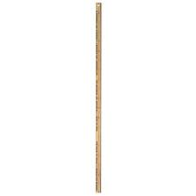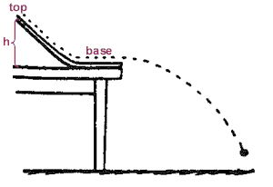

**LAUNCHER**

**X**

**D**

**h**

The table below shows the data they gathered over several trials, where they used successively larger launch speeds **u** and measured the height **h** at which the ball bearing passed by the ruler.

|  |  |  |  |  |  |  |
| --- | --- | --- | --- | --- | --- | --- |
| Launch speed u (m/s) | 1.6 | 2.0 | 2.4 | 2.8 | 3.2 | 3.6 |
| Height h (cm) | 11 | 40 | 56 | 66 | 72 | 76 |
| **height h (m)** | **0.11** | **0.40** | **0.56** | **0.66** | **0.72** | **0.76** |
| **u2 (m2s-2)** | **2.6** | **4.0** | **5.8** | **7.8** | **10.2** | **13.0** |
| **1/u2 (m-2s2)** | **0.39** | **0.25** | **0.17** | **0.13** | **0.098** | **0.077** |

1 mark for values of h (in m), 1 mark for values of 1/u2 , 1 mark for values to only 2 sig figs

The general relationship between vertical displacement Y, horizontal displacement s and speed u for an object launched at angle  to the horizontal is given by

$$Y=s×tan{θ}+\frac{gs^{2}}{2u^{2}{\left(\cos{θ}\right)}^{2}}$$

The relationship the students deduced linking speed u and height h for their experiment was

$$h=\frac{-4.9s^{2}}{u^{2}}+D$$

(a) Show how the students deduced their modified relationship. (3 marks)

**launch angle  = 0° so cos  = 1 and tan  = 0**

**∴ Y = 0 + (1)**

**If up is the positive direction, then $g=-9.8$**

$Y=\frac{-4.9s^{2}}{u^{2}}$

**The height above the ground is the starting height D, plus the displacement Y**

$h=Y+D=\frac{-4.9s^{2}}{u^{2}}+D$

(b) Using the extra rows provided, modify the data in the table so that a linear graph can be obtained using SI units. Give the modified data values an appropriate number of significant figures. (3 marks)

(c) Draw the linear graph on the graph paper on the next page. (an additional copy of the graph paper is available at the back of this paper if needed) (4 marks)

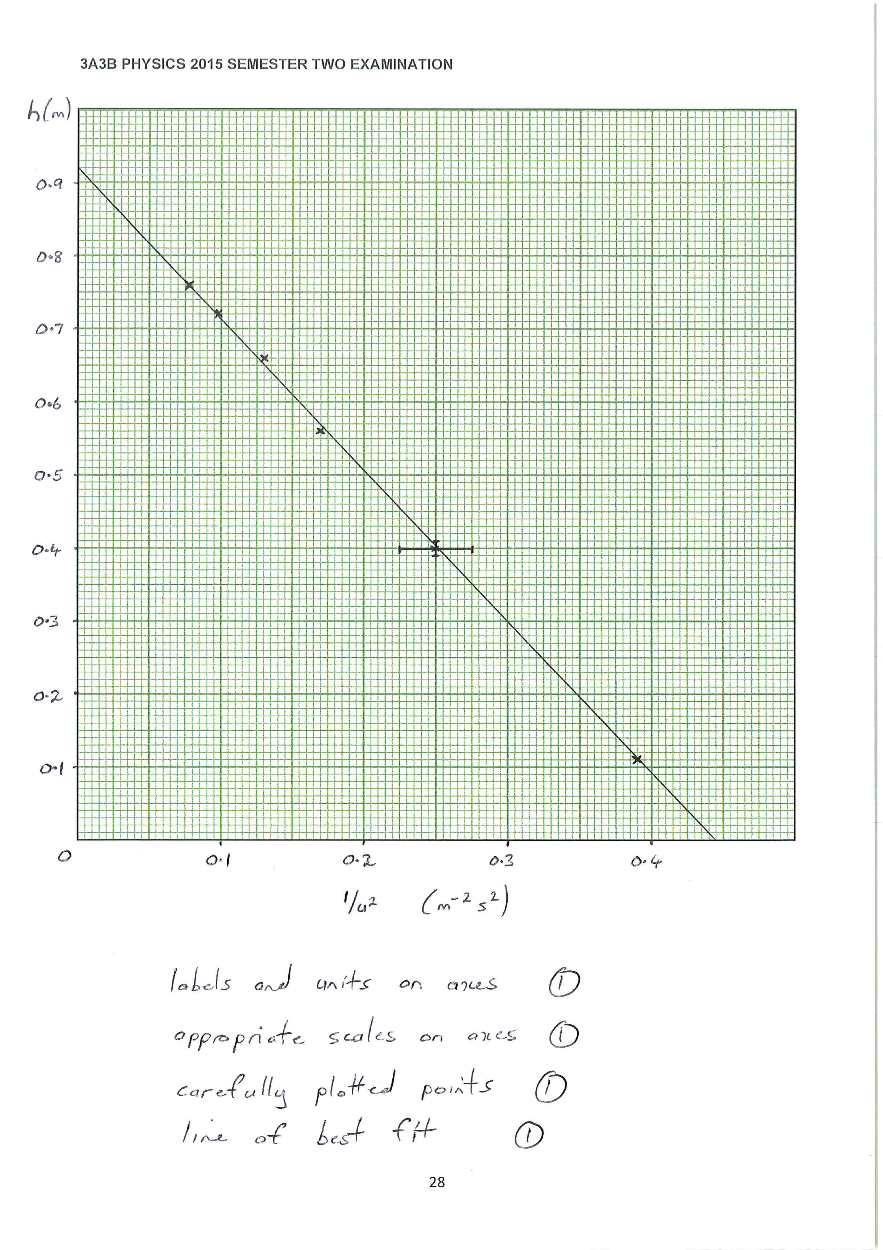

(d) The students estimated that their values for height h were accurate to ± 1 cm while the

launch speed u was accurate to ± 0.1 m/s. Use these estimates to calculate the uncertainty in both the vertical and horizontal variables and hence to plot error bars on the graph, for the point where height h = 40 cm only. (3 marks)

**u = 2.0 m/s ± 5% so u2 = 4.0 m2s-2 ± 10% (1)**

**∴ 1/u2 = 0.25 m-2s2 ± 10% = 0.25 m-2s2 ± 0.025 m-2s2 (1)**

**error bars shown on graph (1)**

(e) Find the gradient of the graph. (3 marks)

**gradient = rise/run = (0 - 0.92 m)/(0.445 m-2s2 - 0) (1)**

**= - 2.07 m3s-2**

**(1) (1)**

(f) Hence calculate the fixed distance X that the ball bearing travelled horizontally from the edge of the table. (2 marks)

**gradient = - 4.9X2 = - 2.07 (1)**

**∴ X2 = 0.422 ➔ X = 0.65 m (65 cm) (1)**

(g) From your graph, find

(i) the height D of the table (1 mark)

**D = vertical intercept = 0.92 m (92 cm) (1)**

(ii) the minimum launch speed needed for the ball bearing to reach the metre ruler while still in the air (before hitting the floor) (2 marks)

**minimum launch speed occurs when h = 0 (1)**

**∴ 1/u2 = 0.445 so u2 = 2.25**

**∴ u = 1.5 m/s (1)**

**Question 24** **LASERS (18 marks)**

(Paragraph 1)

The word 'laser' stands for 'Light Amplification by Stimulated Emission of Radiation'. A laser is an instrument made of a certain material that can be stimulated, by an external energy source, to emit light. Light from everyday sources, such as a light bulb, is produced in a haphazard process called spontaneous emission that gives an incoherent source of light (the photons have a random phase difference), which is then emitted in all directions.

(Paragraph 2)

In the Bohr atomic model, electrons orbit the nucleus with a definite energy, which increases with distance from the centre of the atom. Most atoms are in the ground state with electrons in the lowest energy level - this distribution is called a normal population. If energy is supplied to the atoms then electrons can be forced to higher energy levels (Figure 1) and the atoms are said to be in an excited state. For most substances the absorbed energy is emitted 'spontaneously' (Figure 2) in a very short time, typically less than 10-8 s, as a photon of energy h.

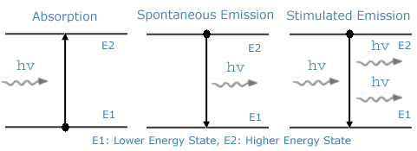 **Figure 1 Figure 2 Figure 3**

(Paragraph 3)

A laser on the other hand requires a substance that has a metastable state (an energy level in which an electron will remain for a time of the order of 10-3 s or longer) and atoms that are in an inverted population (more atoms are in the excited state than in the ground state).

These two conditions are necessary so that the process of stimulated emission can cause a coherent beam of light.

(Paragraph 4)

The stimulated emission process is shown above in Figure 3. When a photon of light of the same energy as the difference between the ground state and excited state hits an excited atom it causes the electron to fall back down to the ground state, emitting light of the same frequency that is in phase with the first photon and travels in the same direction. These photons strike other excited atoms causing an avalanche of photons with the same wavelength and in phase. A monochromatic laser beam is formed by having a resonating tube that has mirrors at each end, one fully reflecting, the other partially reflecting, which allows a small percentage of the photons to pass through.

(Paragraph 5)

The excitation of the atoms in a laser can be done in several ways to produce the necessary inverted population. In a ruby laser, the lasing material is a ruby rod consisting of Al2O3 with a small percentage of aluminium (Al) atoms replaced by chromium (Cr) atoms. The Cr atoms are the ones involved in lasing. The Cr atoms are excited by strong flashes of light of wavelength 540 nm, which 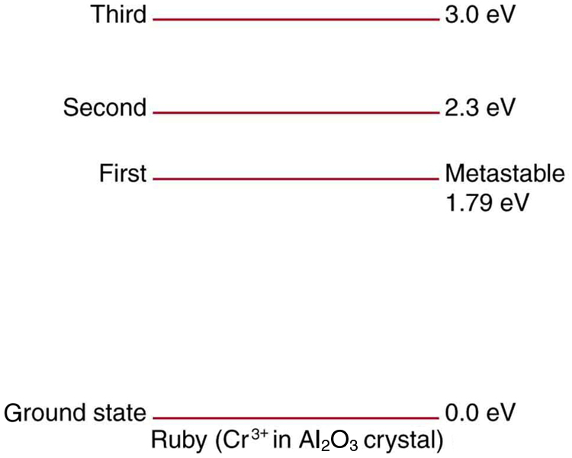correspond to a photon energy of 2.3 eV. As shown in Figure 4 below, the atoms are excited from the ground state to the second excited state. This process is called optical pumping. The atoms quickly decay either back to the ground state or to the intermediate first excited state, which is metastable with a lifetime of about 3 x 10-3 s. With strong pumping action an inverted population can be formed. As soon as a few atoms in the metastable state jump down to the ground state they emit photons that produce stimulated emission and the lasing action begins. A ruby laser thus emits a beam whose photons have energy 1.79 eV and a wavelength of 694.5 nm (or "ruby-red" light).

**Figure 4**: Energy levels of

chromium in a ruby laser.

(a) What are the main differences between an everyday light source and a laser? (Paragraph 1) (2 marks)

**An everyday light source produces incoherent light, where the photons have a random phase difference (1), which is emitted in all directions (1)**

**(whereas a laser produces a tight beam of coherent light, with all photons of the same wavelength and in phase)**

(b) Describe the difference between a normal population of atoms and an inverted population of atoms. (Paragraphs 2 & 3) (2 marks)

**A normal population of atoms is where most atoms are in the ground state (i.e. its electrons are in the lowest possible energy level). (1)**

**An inverted population of atoms is where more atoms are in an excited state than in the ground state. (1)**

(c) Using appropriate terminology as discussed in the article, briefly describe the two conditions that are necessary for stimulated emission to take place. (3 marks)

**The two conditions that are necessary for stimulated emission to occur are:**

* **a substance that has a metastable state (1) i.e. an excited energy level in which an electron will remain for a time longer than a millisecond (1)**
* **atoms that are in an inverted population, with more atoms in the excited state than in the ground state. (1)**

(d) How does the stimulated emission process and design of the laser produce a **coherent beam** of light? (Paragraph 4) (3 marks)

**When a photon hits an excited atom with its electron in the metastable state, it causes the electron to drop to the ground state and emit a photon of the same energy and frequency. (1)**

**These two photons are in phase with each other and travel in the same direction, striking other excited atoms and stimulating further release of photons of the same wavelength and in phase. (1)**

**The laser is a tube containing the lasing material with mirrors at each end, one fully reflecting and the other only partially reflecting, so that some of the photons pass through the partially reflecting mirror and emerge as a coherent laser beam. (1)**

(e) Using a calculation to help support you answer, what part of the electromagnetic spectrum does the transition from the second excited state to the intermediate first excited state in the ruby laser (Figure 4) correspond? What implication does this have on the operation of the laser? (Paragraph 5) (3 marks)

**The transition from the second excited state to the first excited state releases a photon of energy**

**E = 2.30 eV - 1.79 eV = 0.51 eV = 8.16 x 10-20 J**

**E = h f ➔ f = E/h = (8.16 x 10-20 J)/(6.63 x 10-34 Js) (1)**

**∴ f = 1.23 x 1014 Hz < 4 x 1014 Hz ➔ infrared radiation (1)**

**When in operation the lasing material emits infrared radiation, which causes heating of the laser. (1)**

(f) What is the theoretical maximum efficiency of the ruby laser? (2 marks)

**efficiency = $\frac{useful output energy}{total input energy}$ x 100% (1)**

**= $\frac{1.79 eV}{2.30 eV}$ x 100% = 77.8% (1)**

**End of Section Three - End of Questions**

Additional Working Space